**Use Case:**

**[https://github.com/GHamza-Dev/wafin-design-and-conception#use-case-diagram](https://github.com/GHamza-Dev/wafin-design-and-conception" \l "use-case-diagram)**

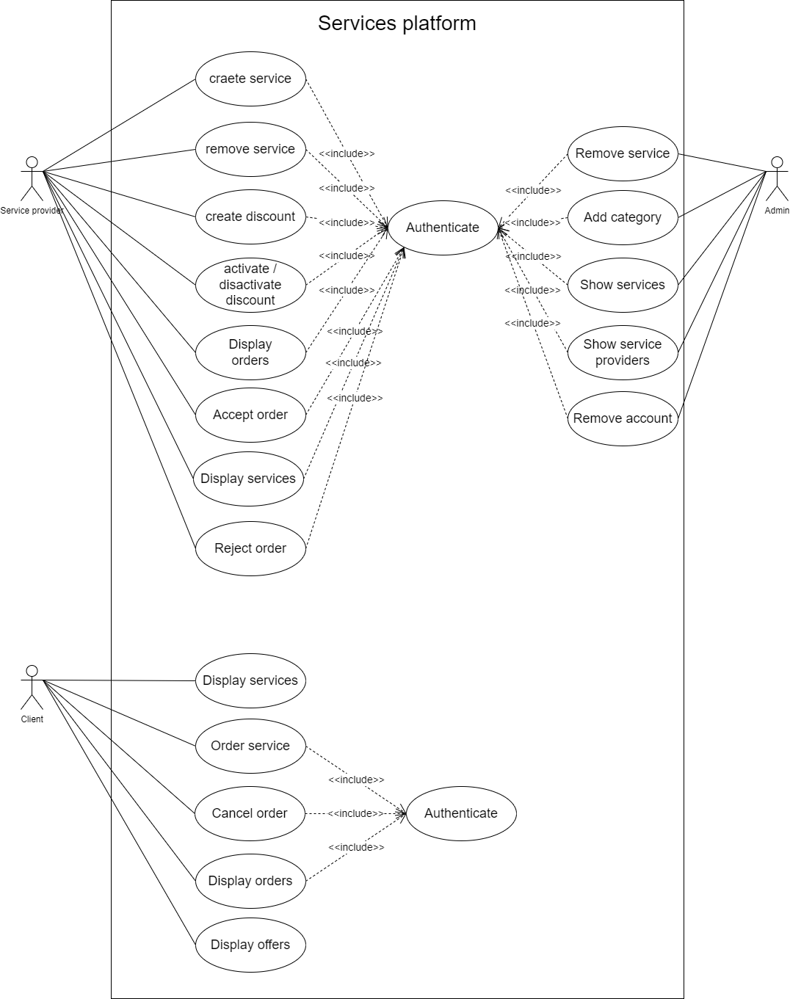

**Class Diagram**

**[https://github.com/GHamza-Dev/wafin-design-and-conception#class-diagram](https://github.com/GHamza-Dev/wafin-design-and-conception" \l "class-diagram)**

**Sequence Diagram**

**[https://github.com/GHamza-Dev/wafin-design-and-conception#sequence-diagram](https://github.com/GHamza-Dev/wafin-design-and-conception" \l "sequence-diagram)**